🔥 **Top Redux Questions**

1. **What is the role of Redux in React? [v.imp.]**

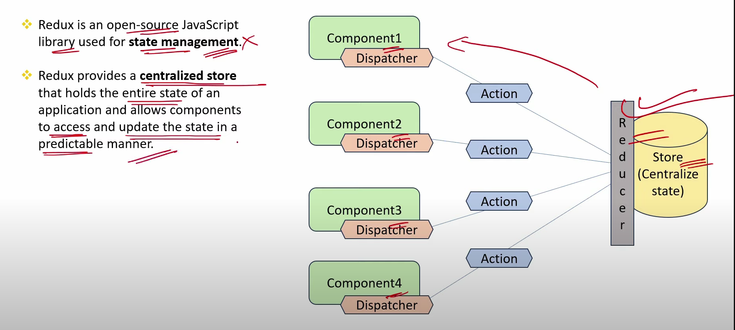

1. **What is the Flow of Data in React While Using Redux? [v.imp.]**

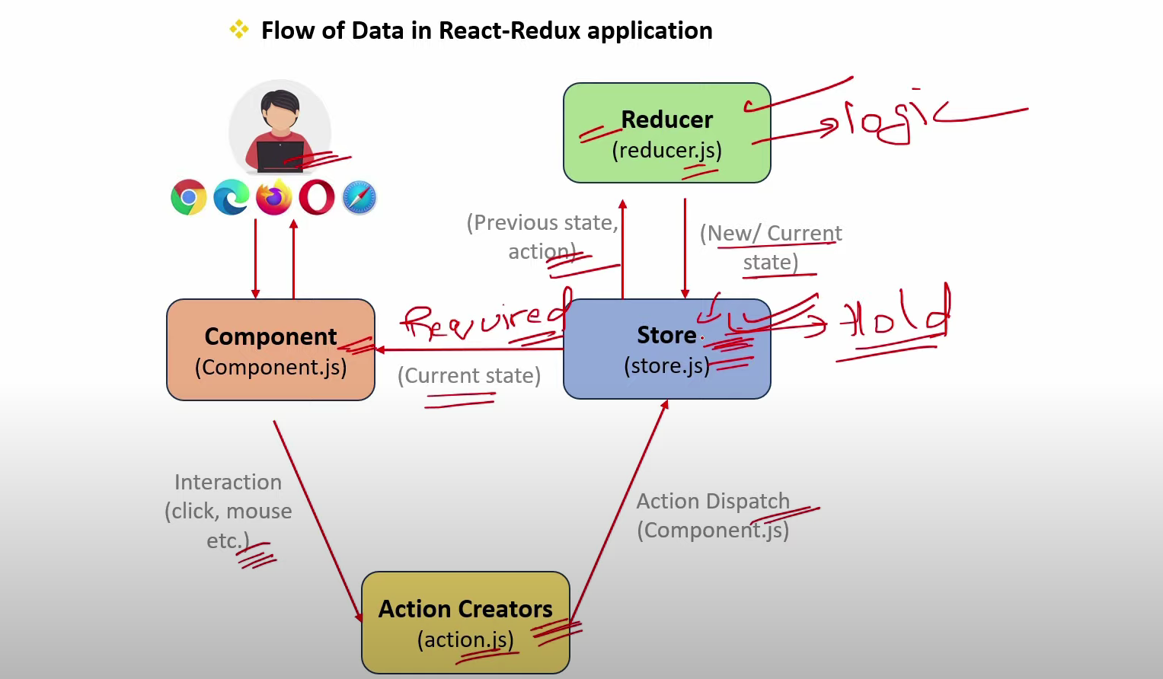

1. **What is the Role of Store in React-Redux? [v.imp]**

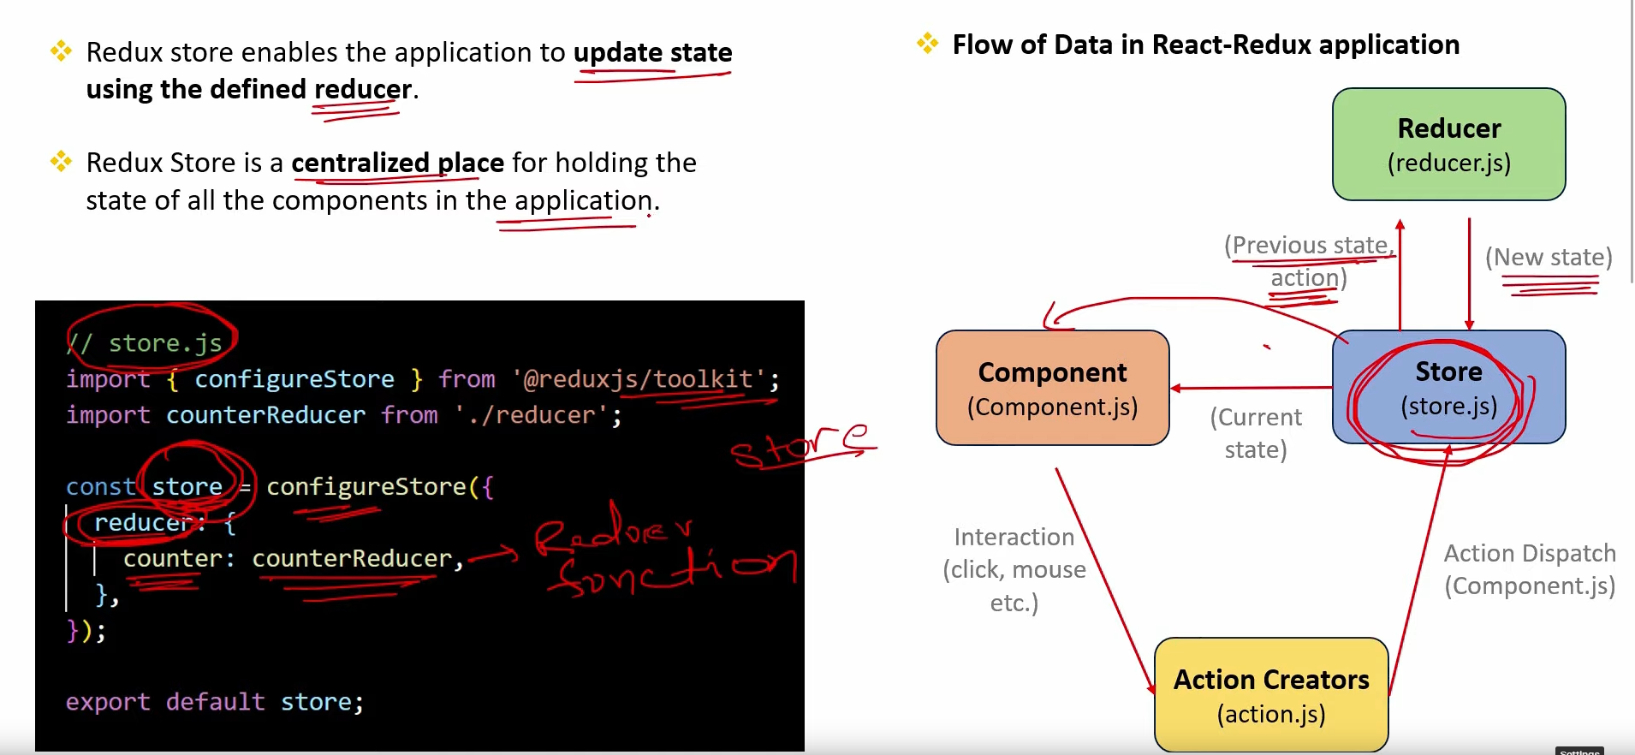

1. **What is the Role of Reducer in React-Redux? [v.imp]**

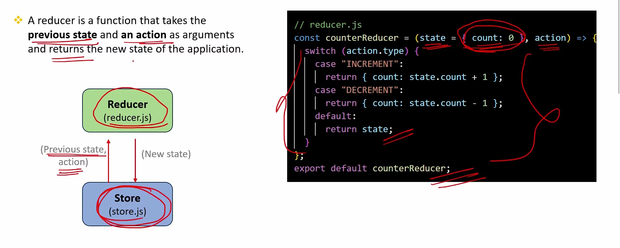

1. **Explain the Core Principles of Redux? [v.imp.]**

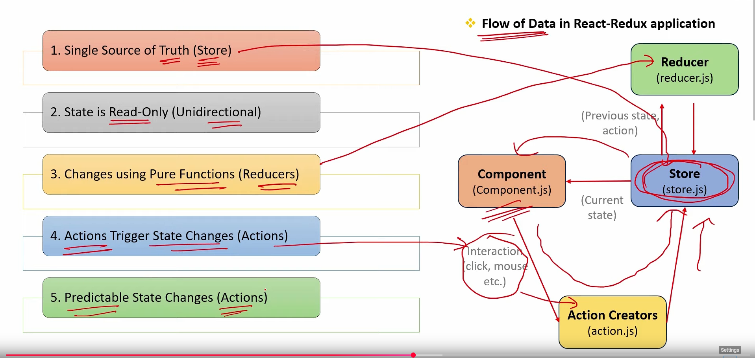

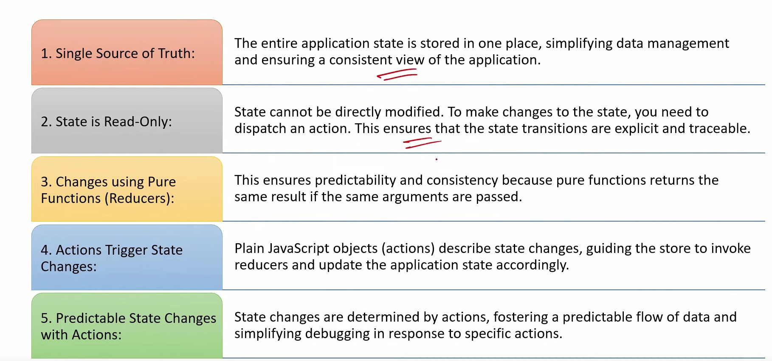

1. **What is the Difference btw local component state & Redux state ?**

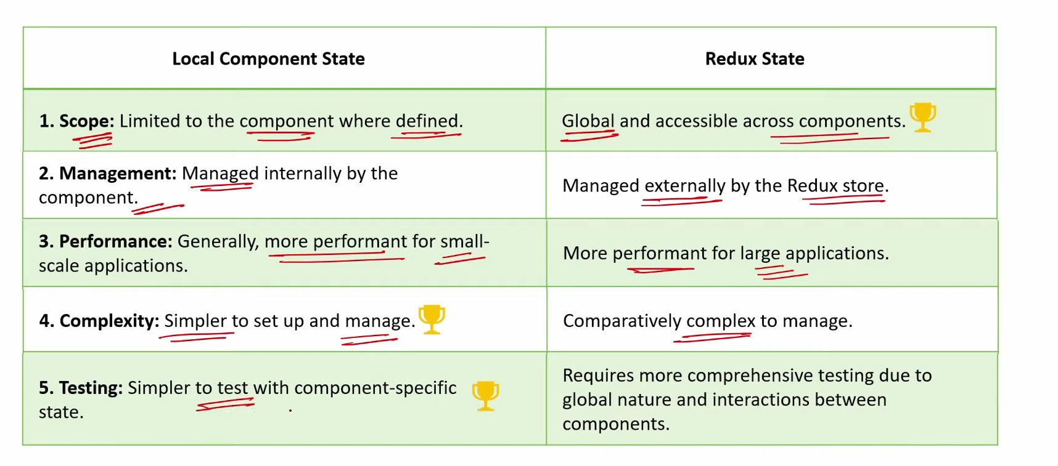

1. **What are the Challenges and disadvantages while using Redux?**

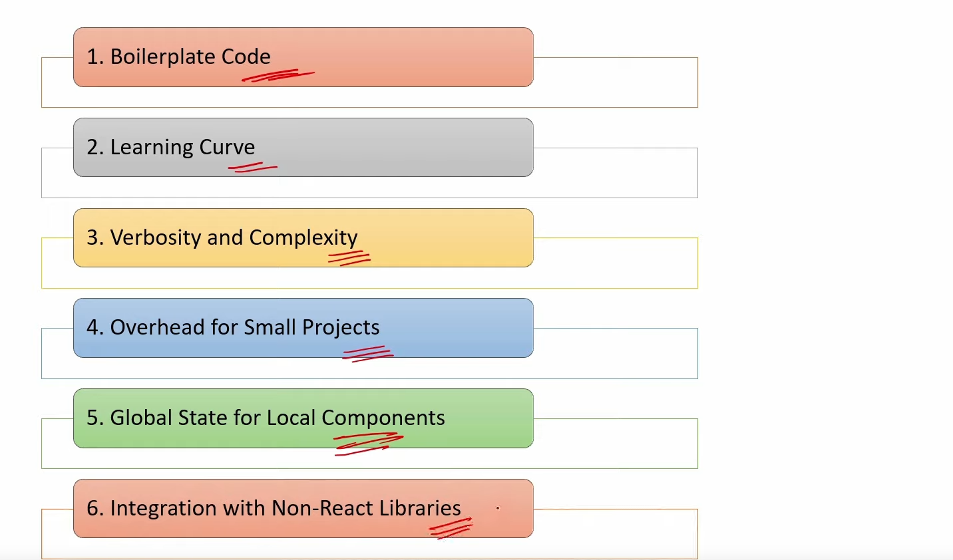

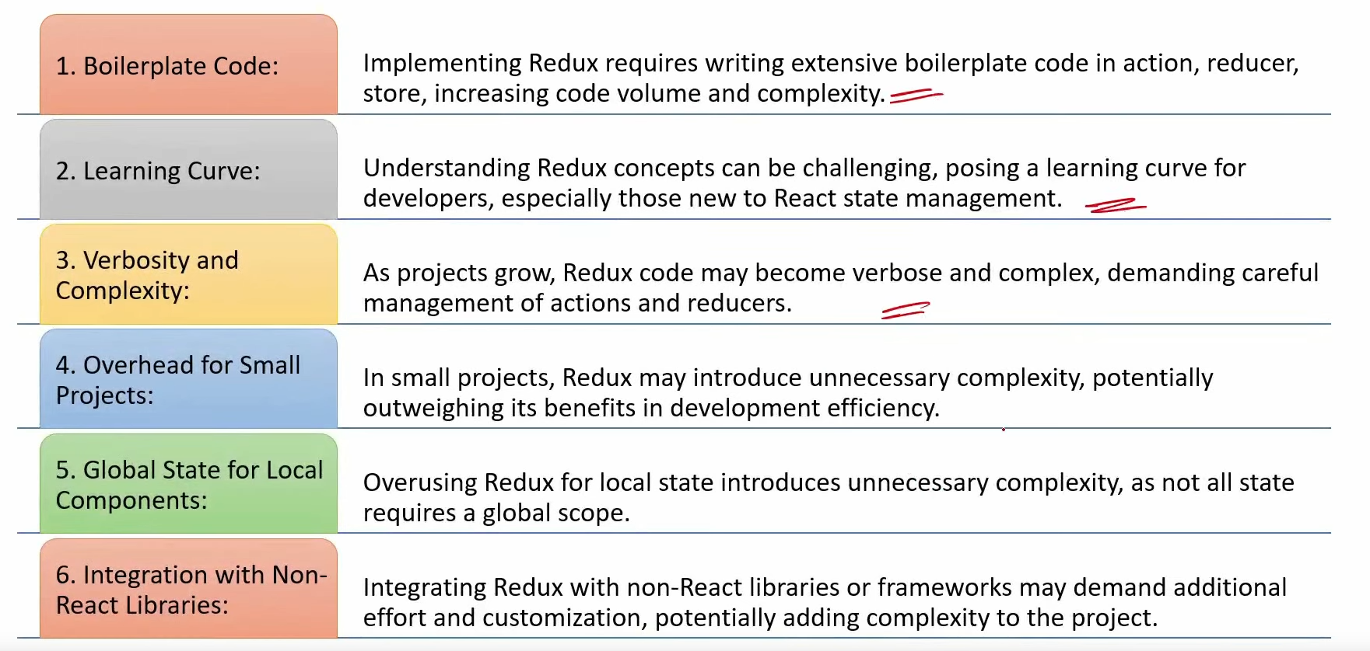

1. **What is a Provider Component ? How component getting the state from Redux Store?**

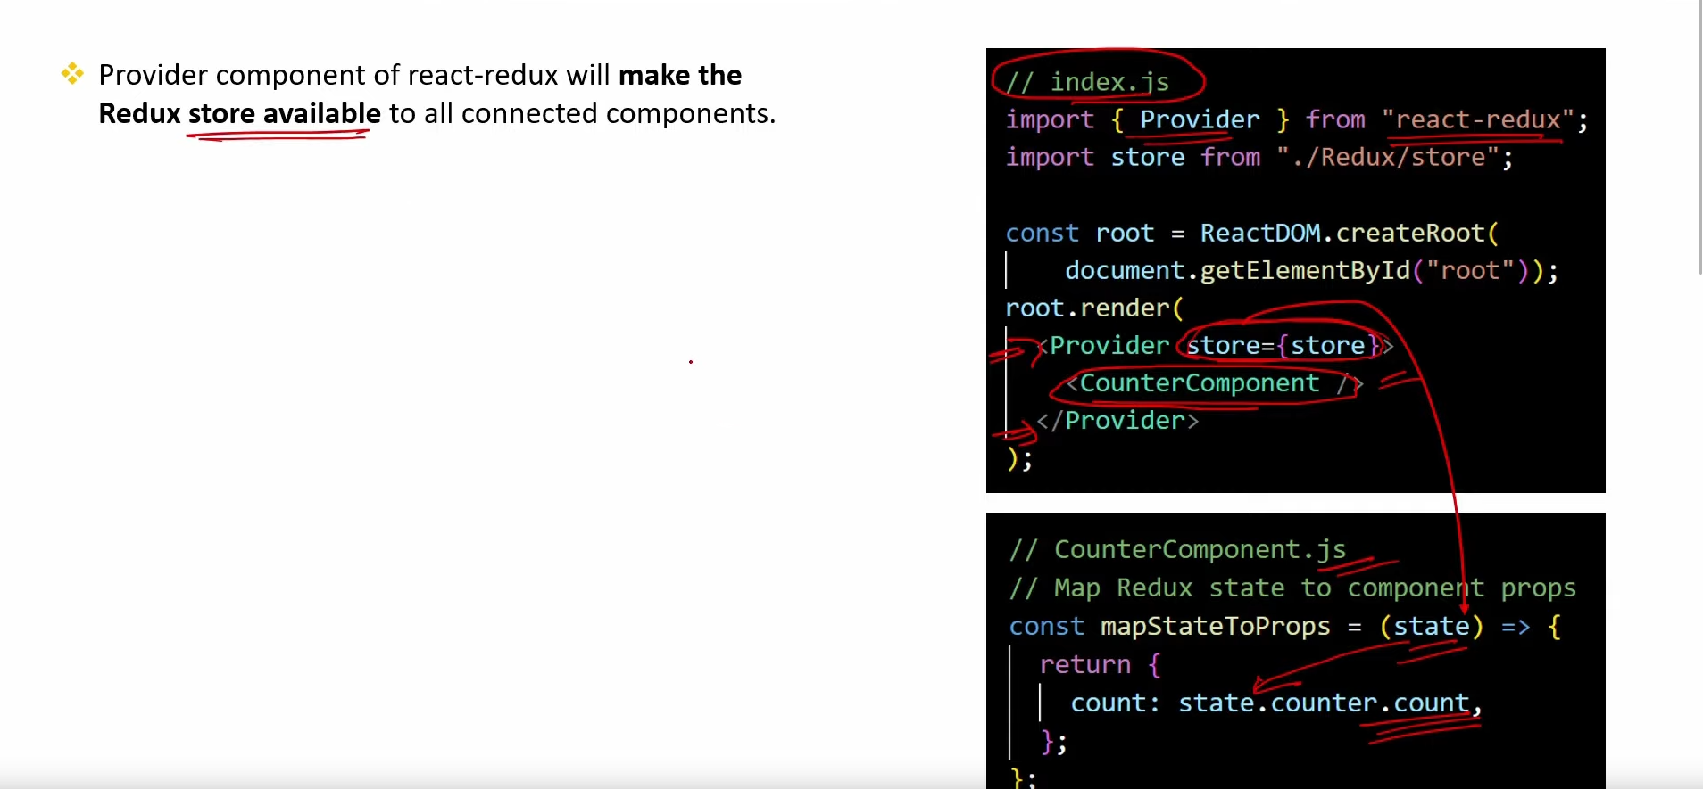

1. **What is the role of Connect function in React-Redux?**

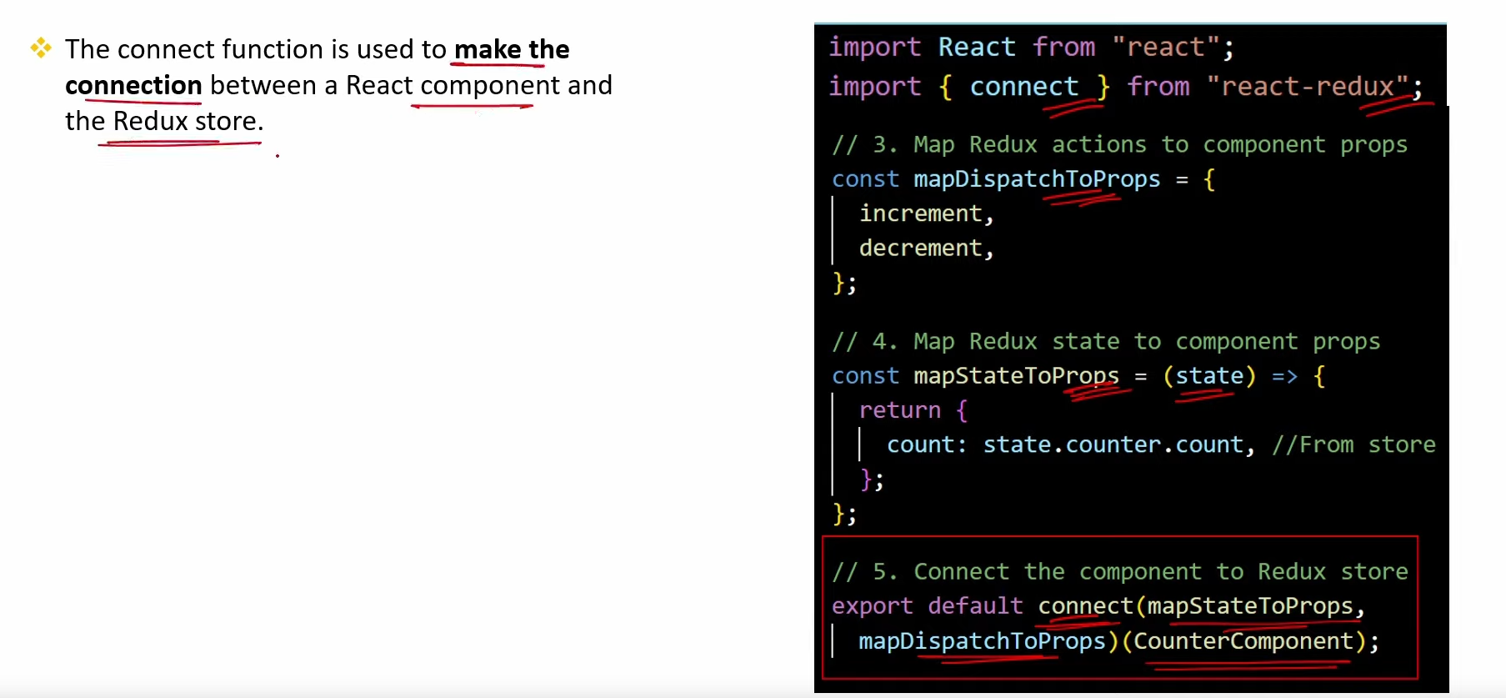

**10.Explain the concept of Middleware in React-Redux?**

